WEEKLY ASSESMENT
QUESTIONS
1. Using a deep learning framework of your choice (TensorFlow, PyTorch, etc.), implement a CNN to classify images from the CIFAR-10 dataset. Ensure your network includes convolutional layers, pooling layers, and fully connected layers. Evaluate the performance of your model and discuss any improvements you could make.

2. Construct a feedforward neural network to predict housing prices based on the provided dataset. Include input normalization, hidden layers with appropriate activation functions, and an output layer. Train the network using backpropagation and evaluate its performance using Mean Squared Error (MSE).

ANSWERS

1.
REQUIREMENTS
1.COMPUTER
2.VS CODE

PROCEDURE
- Open vs code
- Create a folder EXAM
- Create Q1.py in the folder
- Write code in Q1.py

CODE
import tensorflow as tf
from tensorflow.keras import layers, models, datasets

# Load CIFAR-10 dataset
(train_images, train_labels), (test_images, test_labels) = datasets.cifar10.load_data()
train_images, test_images = train_images / 255.0, test_images / 255.0

# Define the CNN model
model = models.Sequential([
layers.Conv2D(32, (3, 3), activation='relu', input_shape=(32, 32, 3)),
layers.MaxPooling2D((2, 2)),
layers.Conv2D(64, (3, 3), activation='relu'),
layers.MaxPooling2D((2, 2)),
layers.Conv2D(64, (3, 3), activation='relu'),
layers.Flatten(),
layers.Dense(64, activation='relu'),
layers.Dense(10, activation='softmax')
])

# Compile the model
model.compile(optimizer='adam',
loss='sparse_categorical_crossentropy',
metrics=['accuracy'])

# Train the model
history = model.fit(train_images, train_labels, epochs=10, batch_size=64,
validation_data=(test_images, test_labels))

# Evaluate the model
test_loss, test_acc = model.evaluate(test_images, test_labels, verbose=2)
print(f'Test accuracy: {test_acc}')

.install require libraries
.run the file using py q1.py

OUTPUT
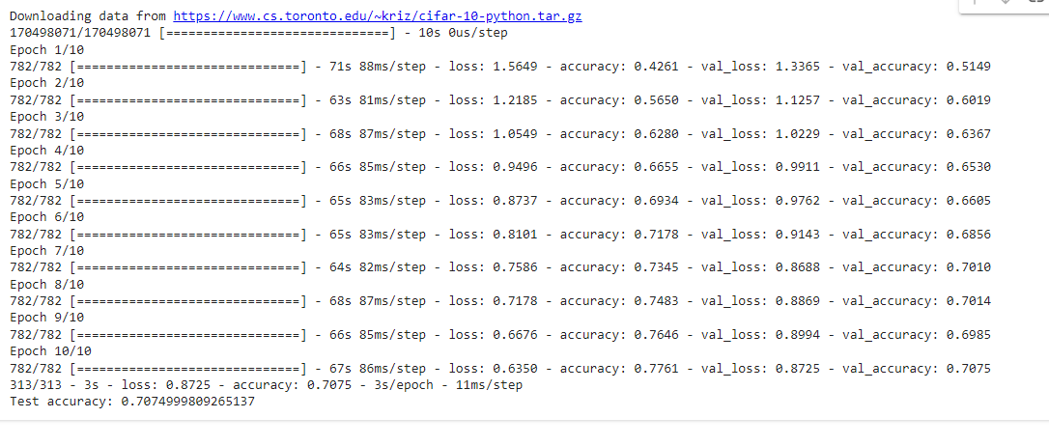

2.
REQUIREMENTS
1.COMPUTER
2.VS CODE

PROCEDURE
- Open vs code
- Create a folder EXAM
- Create Q2.py in the folder
- Write code in Q1.py

CODE
import pandas as pd
from sklearn.model_selection import train_test_split
from sklearn.preprocessing import StandardScaler, OneHotEncoder
from sklearn.compose import ColumnTransformer
from sklearn.pipeline import Pipeline
from tensorflow.keras.models import Sequential
from tensorflow.keras.layers import Dense
from tensorflow.keras.optimizers import Adam

# Load data
try:
data = pd.read_csv('housing_prices.csv')
except FileNotFoundError as e:
print(f"FileNotFoundError: {e}. Make sure the file path is correct and accessible.")
exit()

# Check if 'Price' column exists
if 'Price' not in data.columns:
print("Error: 'Price' column not found in the dataset.")
print("Columns available in the dataset:")
print(data.columns)
exit()

# Separate features and target
X = data.drop('Price', axis=1)
y = data['Price']

# Split data into train and test sets
X_train, X_test, y_train, y_test = train_test_split(X, y, test_size=0.2, random_state=42)

# Define column transformer for preprocessing
numeric_features = ['Bedrooms', 'Bathrooms', 'SquareFootage', 'Age']
categorical_features = ['Location']

numeric_transformer = Pipeline(steps=[
('scaler', StandardScaler())
])

categorical_transformer = Pipeline(steps=[
('onehot', OneHotEncoder(handle_unknown='ignore'))
])

preprocessor = ColumnTransformer(
transformers=[
('num', numeric_transformer, numeric_features),
('cat', categorical_transformer, categorical_features)
])

# Fit and transform the training data
X_train_processed = preprocessor.fit_transform(X_train)
X_test_processed = preprocessor.transform(X_test)

# Determine the input shape
input_shape = X_train_processed.shape[1]

# Define the neural network
model = Sequential([
Dense(64, activation='relu', input_shape=(input_shape,)),
Dense(64, activation='relu'),
Dense(1) # Output layer for regression, no activation function
])

# Compile the model
model.compile(optimizer=Adam(), loss='mean_squared_error')

# Train the model
history = model.fit(X_train_processed, y_train, epochs=50, batch_size=8, validation_split=0.2)

# Evaluate the model
mse = model.evaluate(X_test_processed, y_test)
print(f'Mean Squared Error on test set: {mse}')

.install require libraries
.run the file using py q2.py

OUTPUT

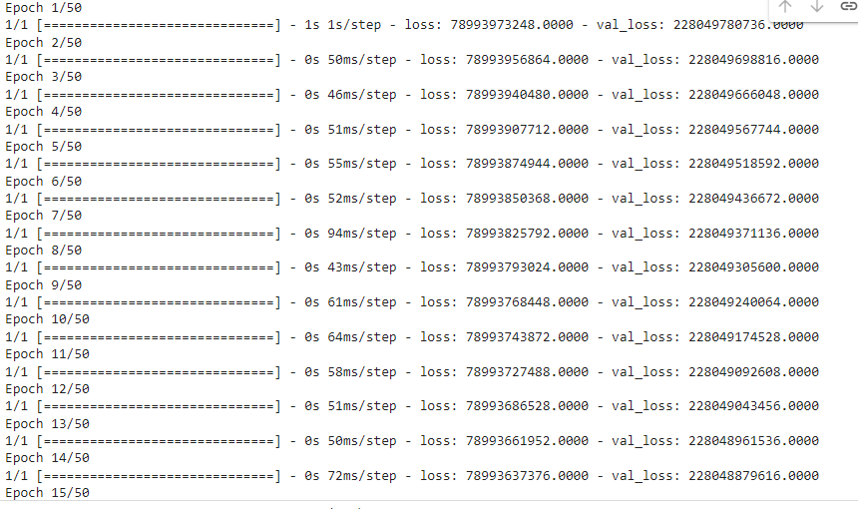

SHIBNU M

